Demo Document

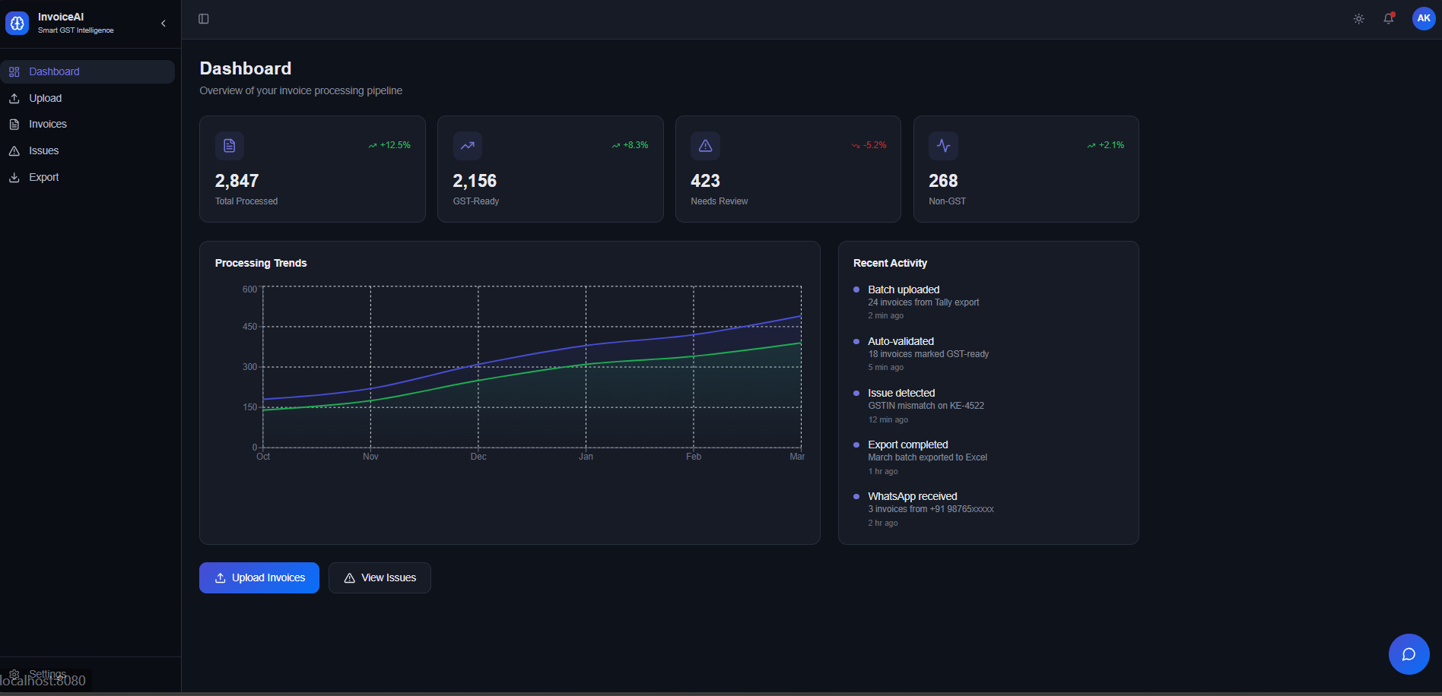
Dashboard Description: Main overview screen of Invoice AI showing invoice processing stats with a processing trends line graph and recent activity feed.
Feature: Real-time processing trends chart tracking GST-Ready vs. total invoices from Oct to Mar, with live activity log showing batch uploads, auto-validations, and export events.

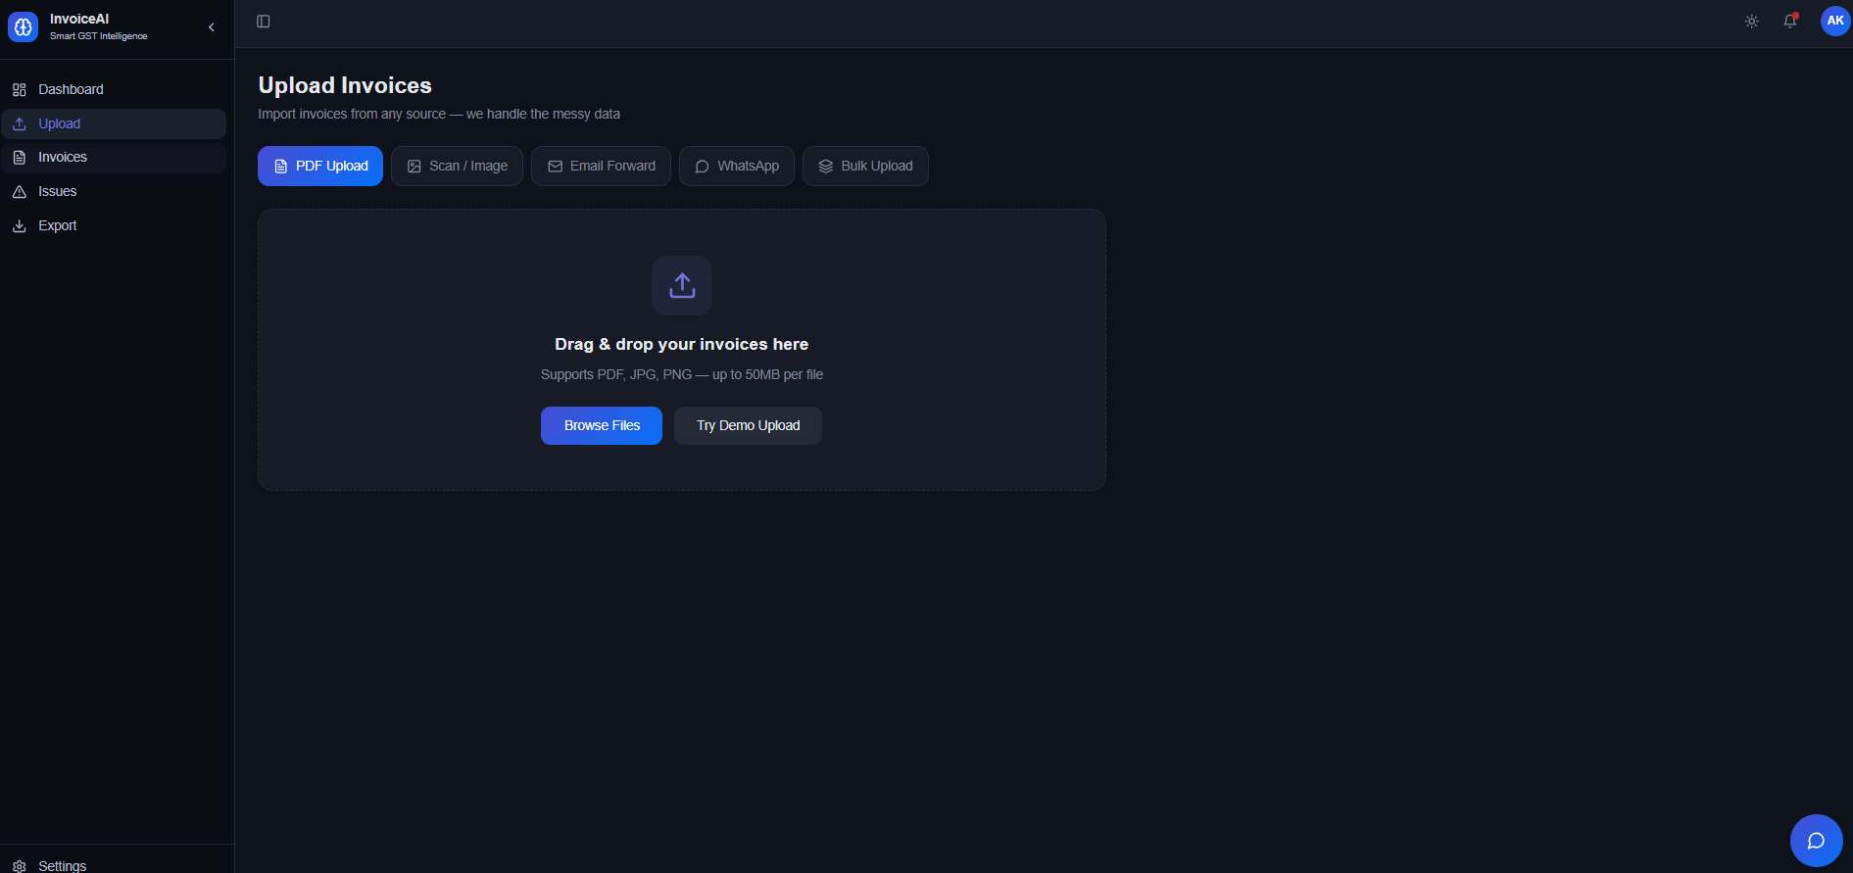
Upload Description: Invoice upload screen with a drag-and-drop zone supporting PDF, JPG, and PNG files up to 50MB, with tabs for multiple upload methods.
Feature: Multi-source upload support via PDF Upload, Scan/Image, Email Forward, WhatsApp, & Bulk Upload tabs all accessible from a single screen.
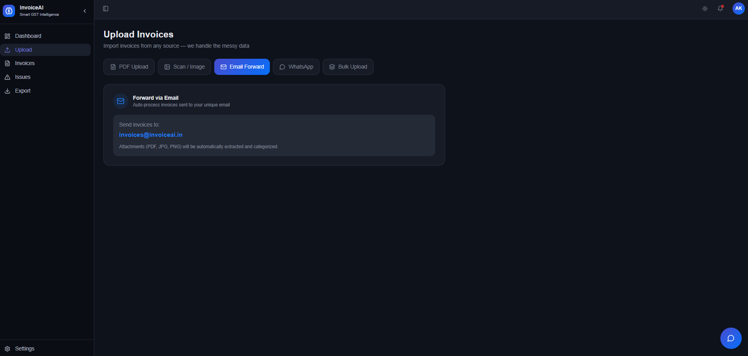
Upload (Email Forward tab) Description: Email forwarding option that lets users auto-process invoices by sending them to a dedicated InvoiceAI email address (invoices@invoiceai.in).
Feature: Automatic attachment extraction and categorization for PDF, JPG, and PNG files received via email, with zero manual intervention

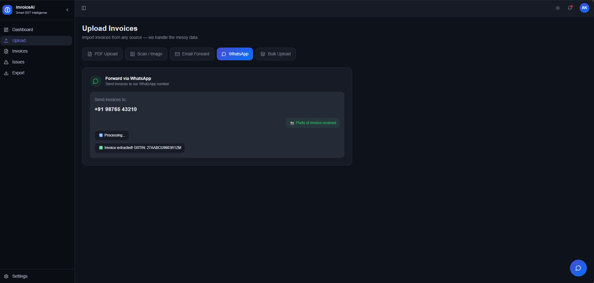
Upload (WhatsApp tab) Description: WhatsApp invoice submission screen where users send invoice with real-time processing and GSTIN extraction confirmation.
Feature: Instant WhatsApp-based invoice ingestion with live chat-style feedback showing processing status and extracted GSTIN directly in the UI.

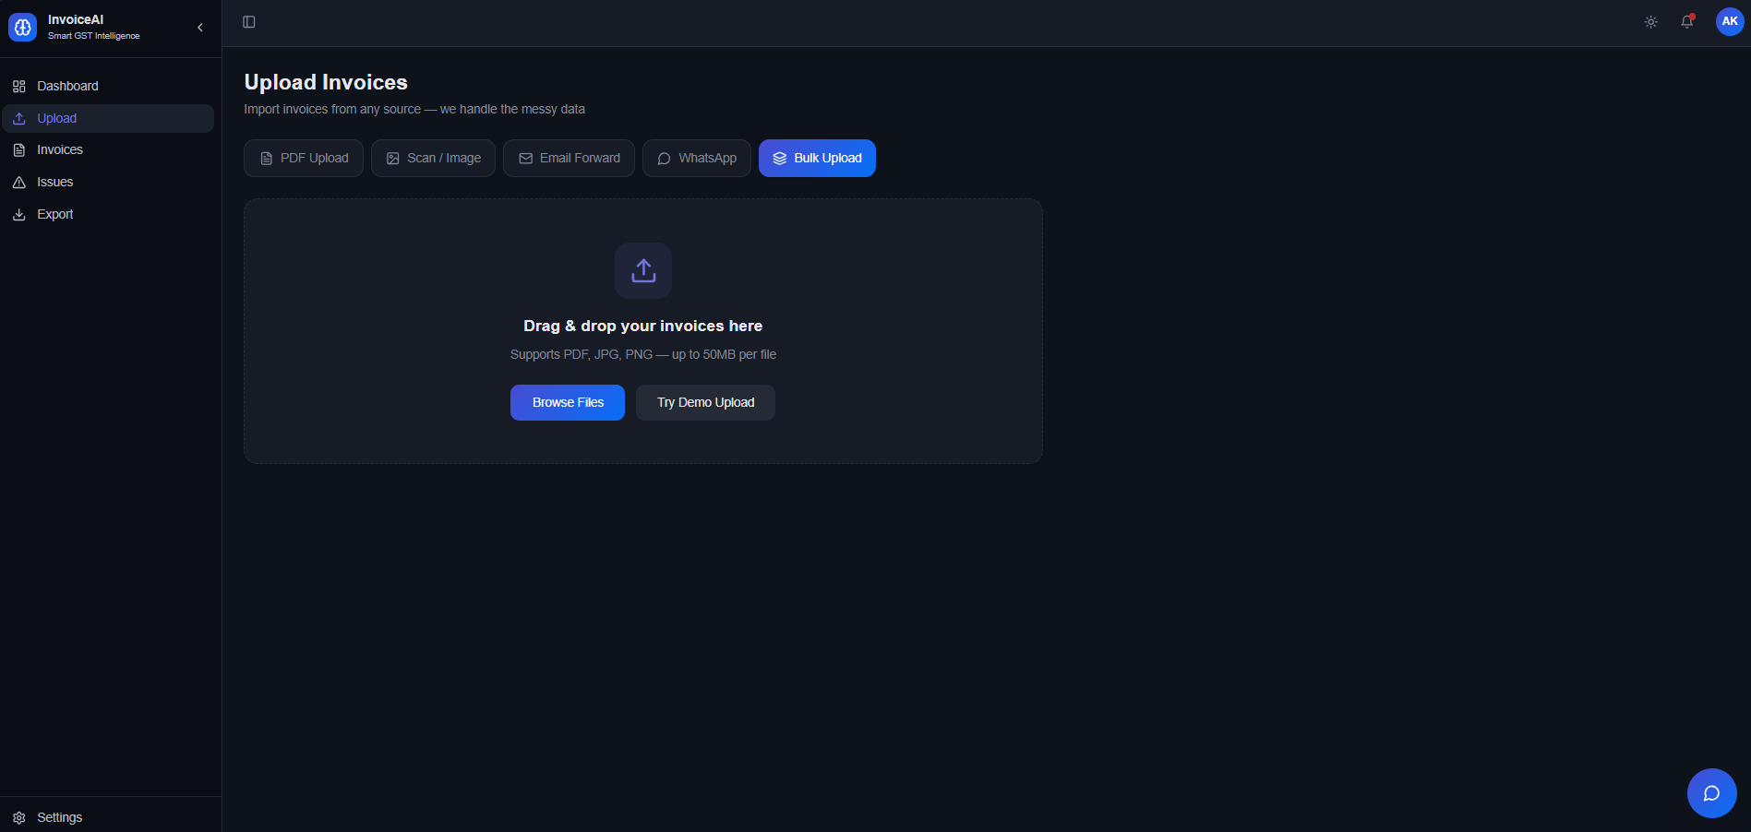
Upload (Bulk Upload tab) Description: Bulk upload interface identical in layout to the PDF upload, allowing large batches of invoices to be dragged and dropped or browsed for upload.
Feature: Supports bulk drag-and-drop invoice submission (PDF, JPG, PNG up to 50MB per file) with a demo upload option for first-time testing.

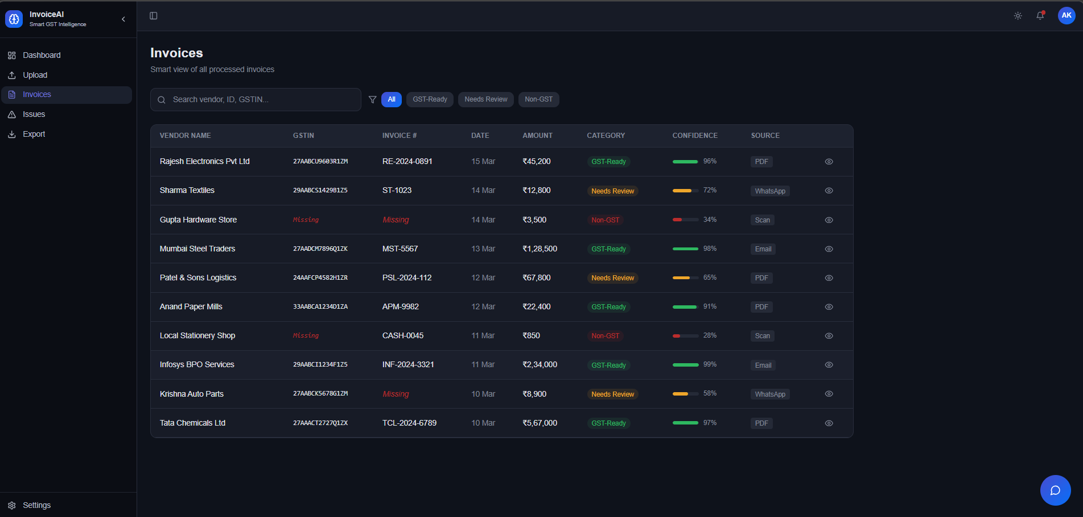
Invoices (All tab) Description: Smart invoice list view showing all processed invoices with vendor name, GSTIN, invoice number, date, amount, GST category, AI confidence score, and source channel.
Feature: Color-coded GST categorization (GST-Ready in green, Needs Review in orange, Non-GST in red) with per-invoice confidence scores and multi-source tagging (PDF, Email, WhatsApp, Scan).

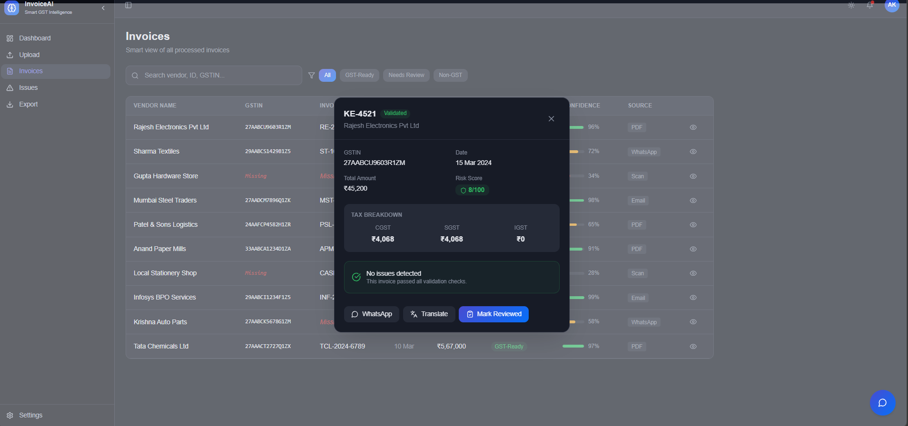
Invoice Detail (Validated) Description: Invoice detail popup for KE-4521 (Rajesh Electronics Pvt Ltd) showing GSTIN, date, total amount (₹45,200), tax breakdown (CGST/SGST/IGST), and a risk score of 8/100.
Feature: Full tax breakdown with CGST, SGST, and IGST split, validation status badge, low risk score indicator, and one-click actions for WhatsApp sharing, translation, and marking as reviewed.

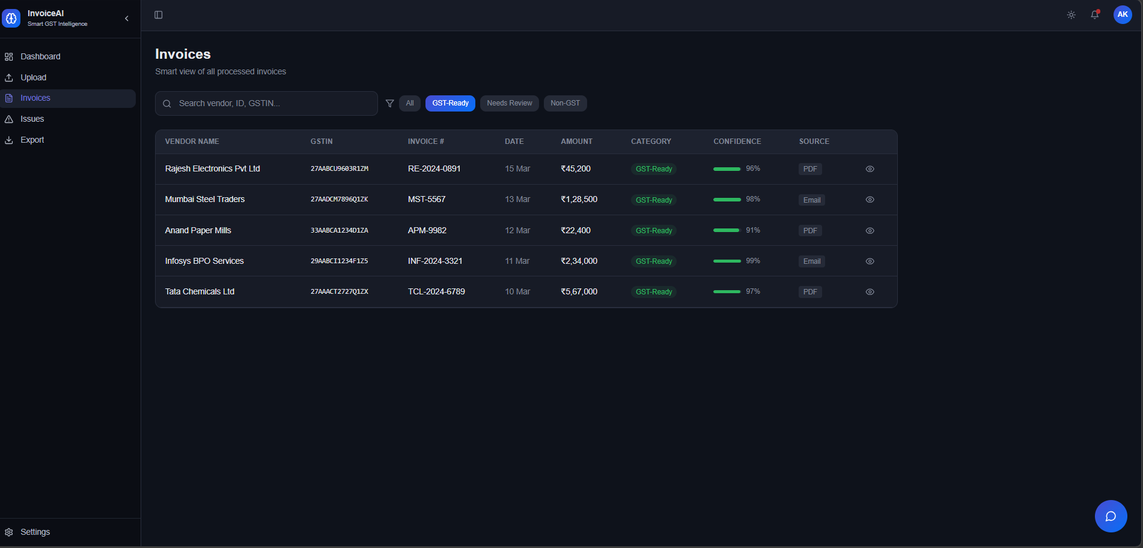
Invoices (GST-Ready filter) Description: Filtered invoice list showing only GST-Ready invoices (Rajesh Electronics, Mumbai Steel Traders, Anand Paper Mills, Infosys BPO Services, Tata Chemicals) with high confidence scores (91–99%).
Feature: One-click GST-Ready filter that instantly isolates compliant invoices ready for filing, with confidence bars and source channel shown per entry.

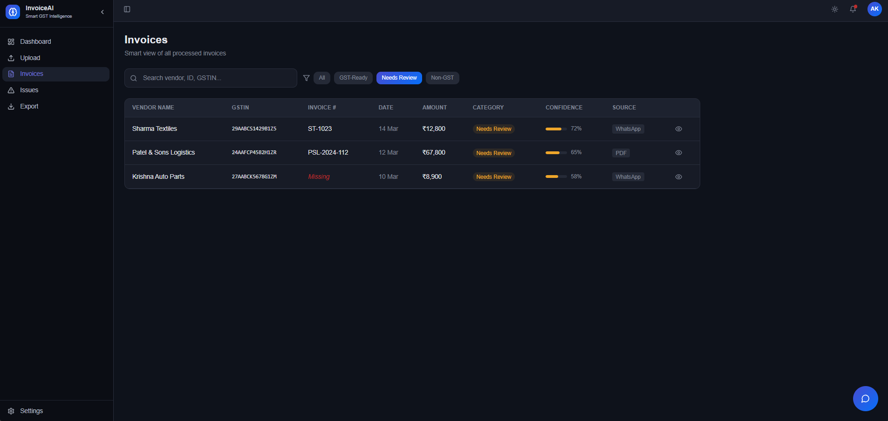
Invoices (Needs Review filter) Description: Filtered view showing 3 invoices flagged as Needs Review — Sharma Textiles, Patel & Sons Logistics, and Krishna Auto Parts — with confidence scores ranging from 58–72%.
Feature: Dedicated "Needs Review" filter highlighting invoices with low confidence or missing data (e.g., missing GSTIN), helping users prioritize manual verification efficiently.

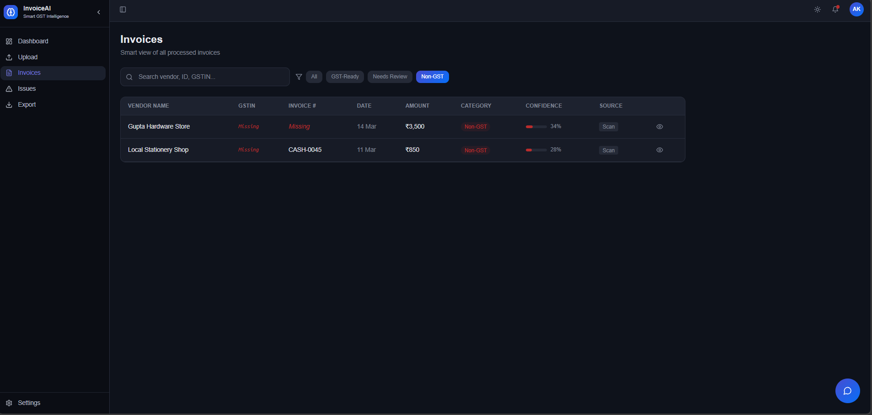
Invoices (Non-GST filter) Description: Non-GST filtered view showing Gupta Hardware Store and Local Stationery Shop, both with missing GSTIN and invoice number, flagged with very low confidence scores (28–34%).
Feature: Non-GST category filter that surfaces unregistered or cash-based vendor invoices with missing fields clearly highlighted in red for quick identification.

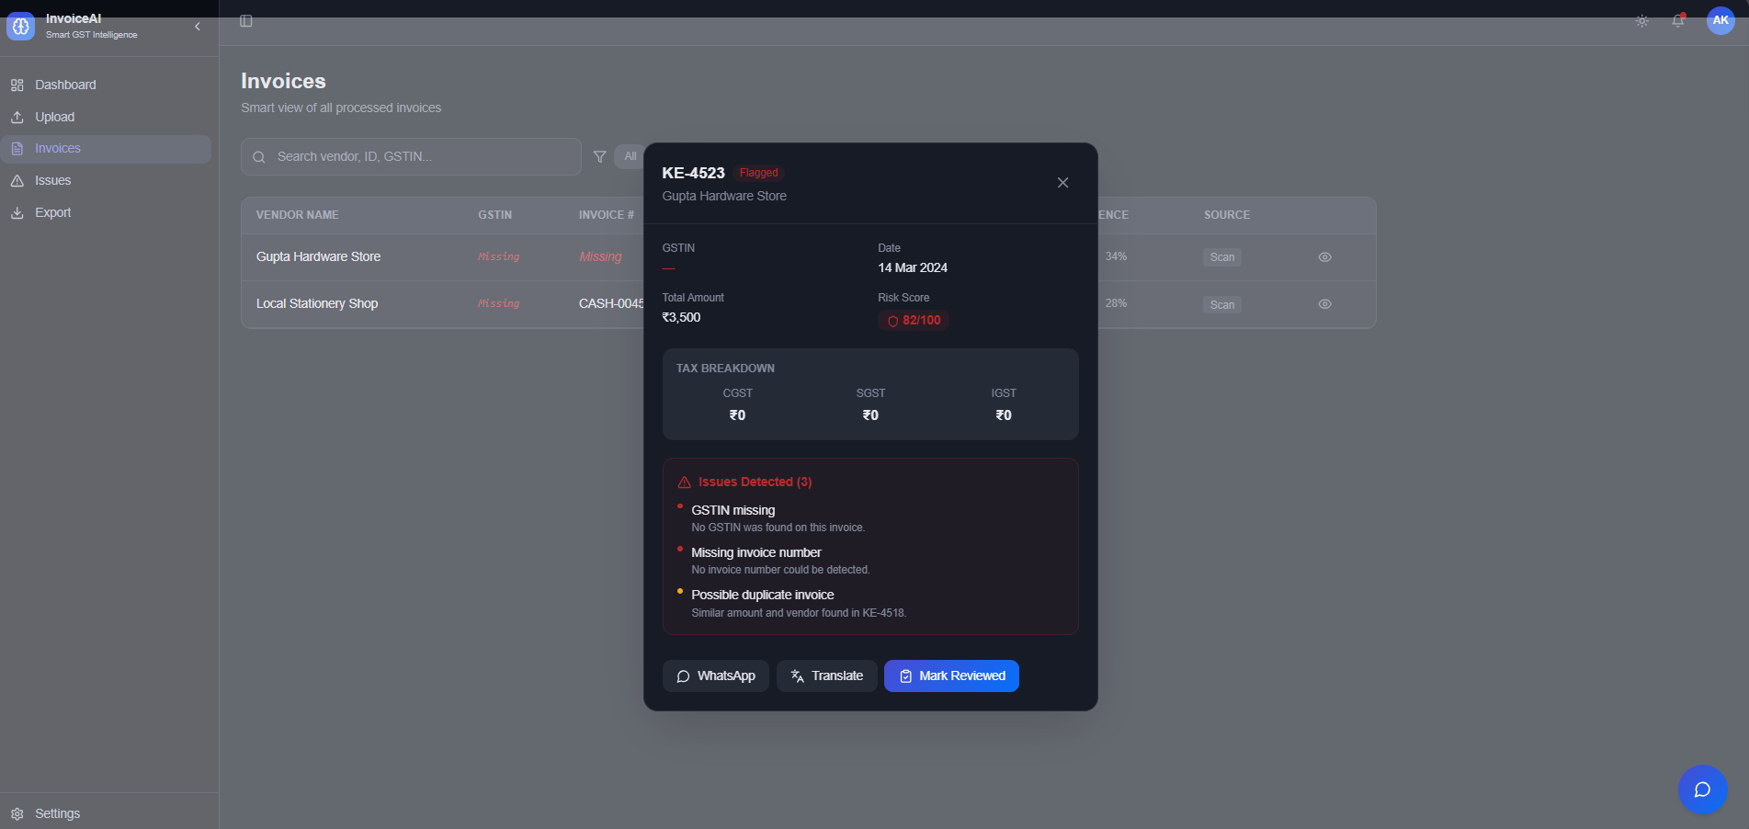
Invoice Detail (Flagged) Description: Invoice detail popup for KE-4523 (Gupta Hardware Store) marked as Flagged with a high risk score of 82/100, showing 3 detected issues — missing GSTIN, missing invoice number, and possible duplicate.
Feature: AI-powered issue detection listing specific problems (GSTIN missing, missing invoice number, possible duplicate) with severity indicators and a one-click "Mark Reviewed" action.

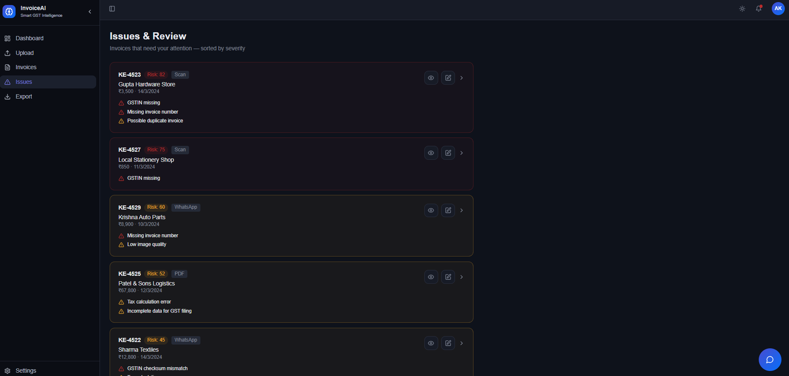
Issues & Review Description: Issues & Review screen listing all flagged invoices sorted by risk severity, with each card showing the risk score, source, vendor name, amount, and specific issues detected.
Feature: Severity-sorted issue queue with per-invoice risk scores (e.g., Risk: 82, 75, 60) and detailed issue tags (GSTIN missing, tax calculation error, duplicate) for efficient manual review.

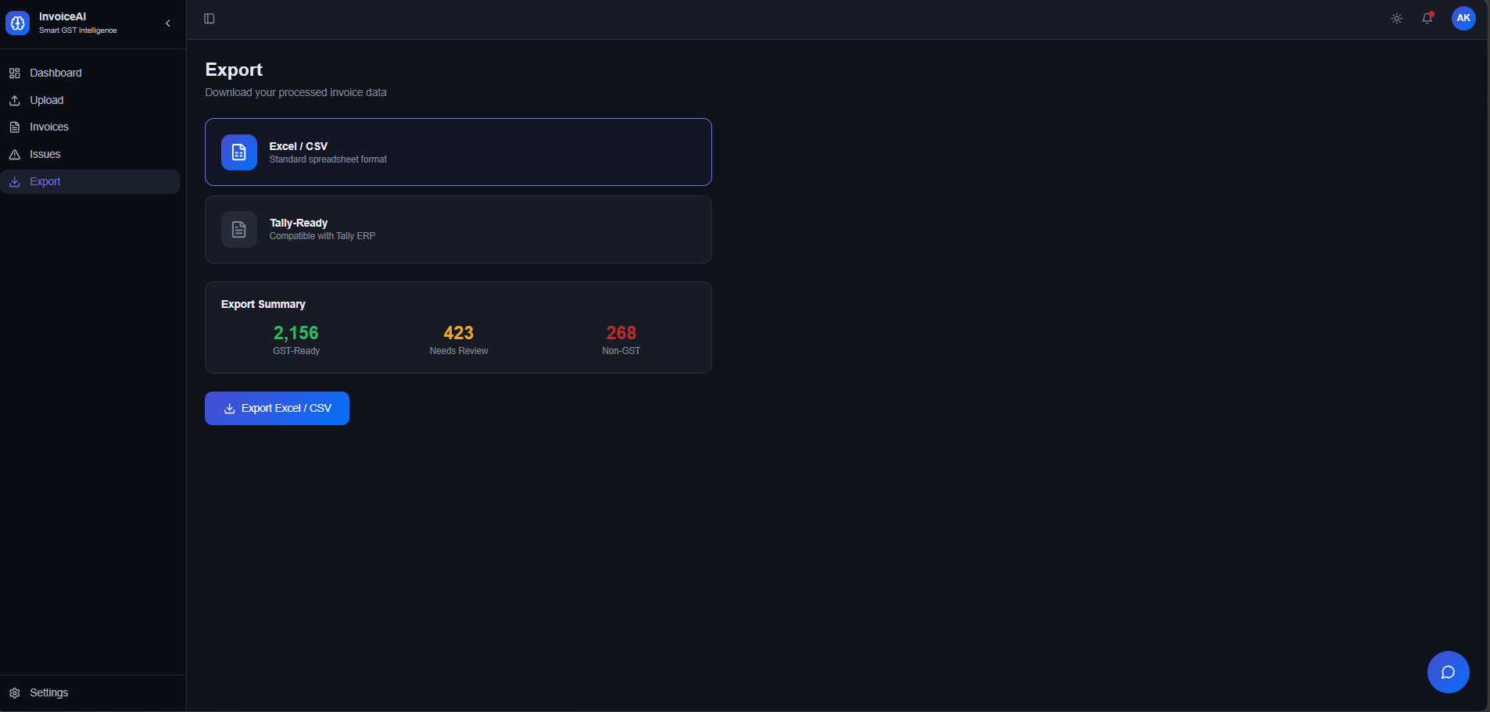
Export Description: Export screen showing download options for processed invoice data in Excel/CSV (standard spreadsheet) and Tally-Ready (Tally ERP compatible) formats, with a summary of 2,156 GST-Ready, 423 Needs Review, and 268 Non-GST invoices.
Feature: One-click Export Excel/CSV button with a pre-export summary breakdown by category, and Tally ERP compatibility for direct accounting software integration.

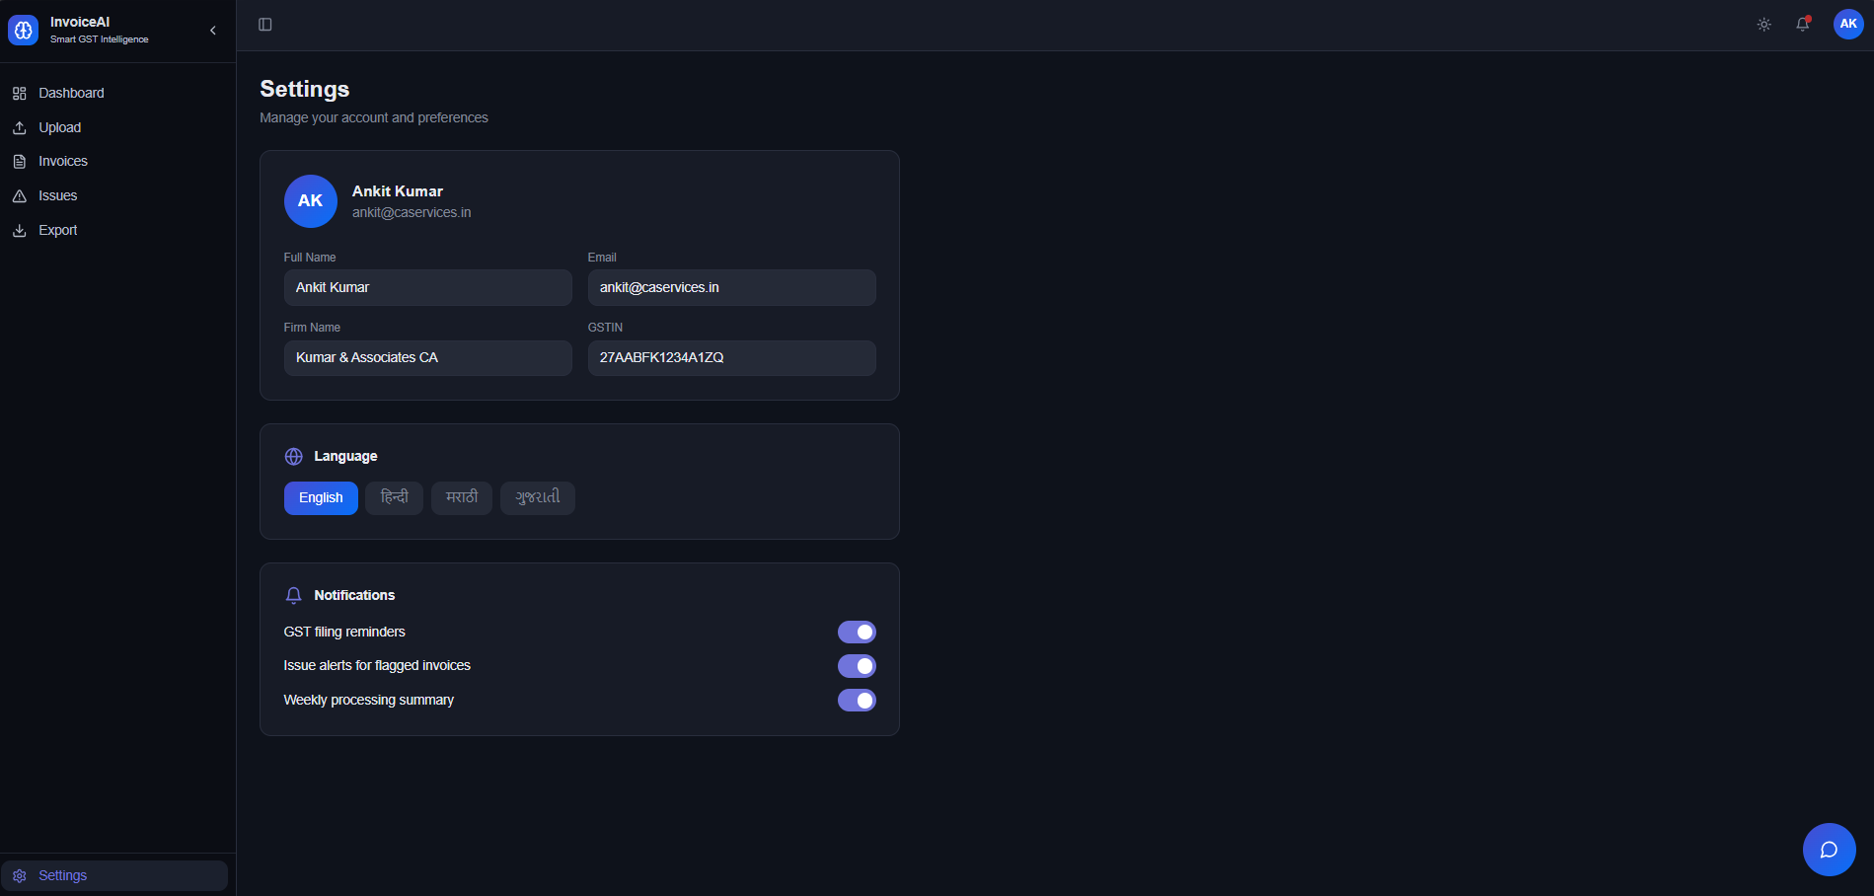
Settings Description: Settings page for user Ankit Kumar (Kumar & Associates CA) with editable profile fields (name, email, firm name, GSTIN), language selection (English, Hindi, Marathi, Gujarati), and notification toggles.
Feature: Multi-language support (English, Hindi, Marathi, Gujarati) with configurable notifications for GST filing reminders, flagged invoice alerts, and weekly processing summaries.

